Nama : MUHAMMAD ADVIE RIFALDY

Kelas : Flutter A

**Tugas Minggu 9**

**Introduction To AI**

1. OpenAI

**Screenshot:**

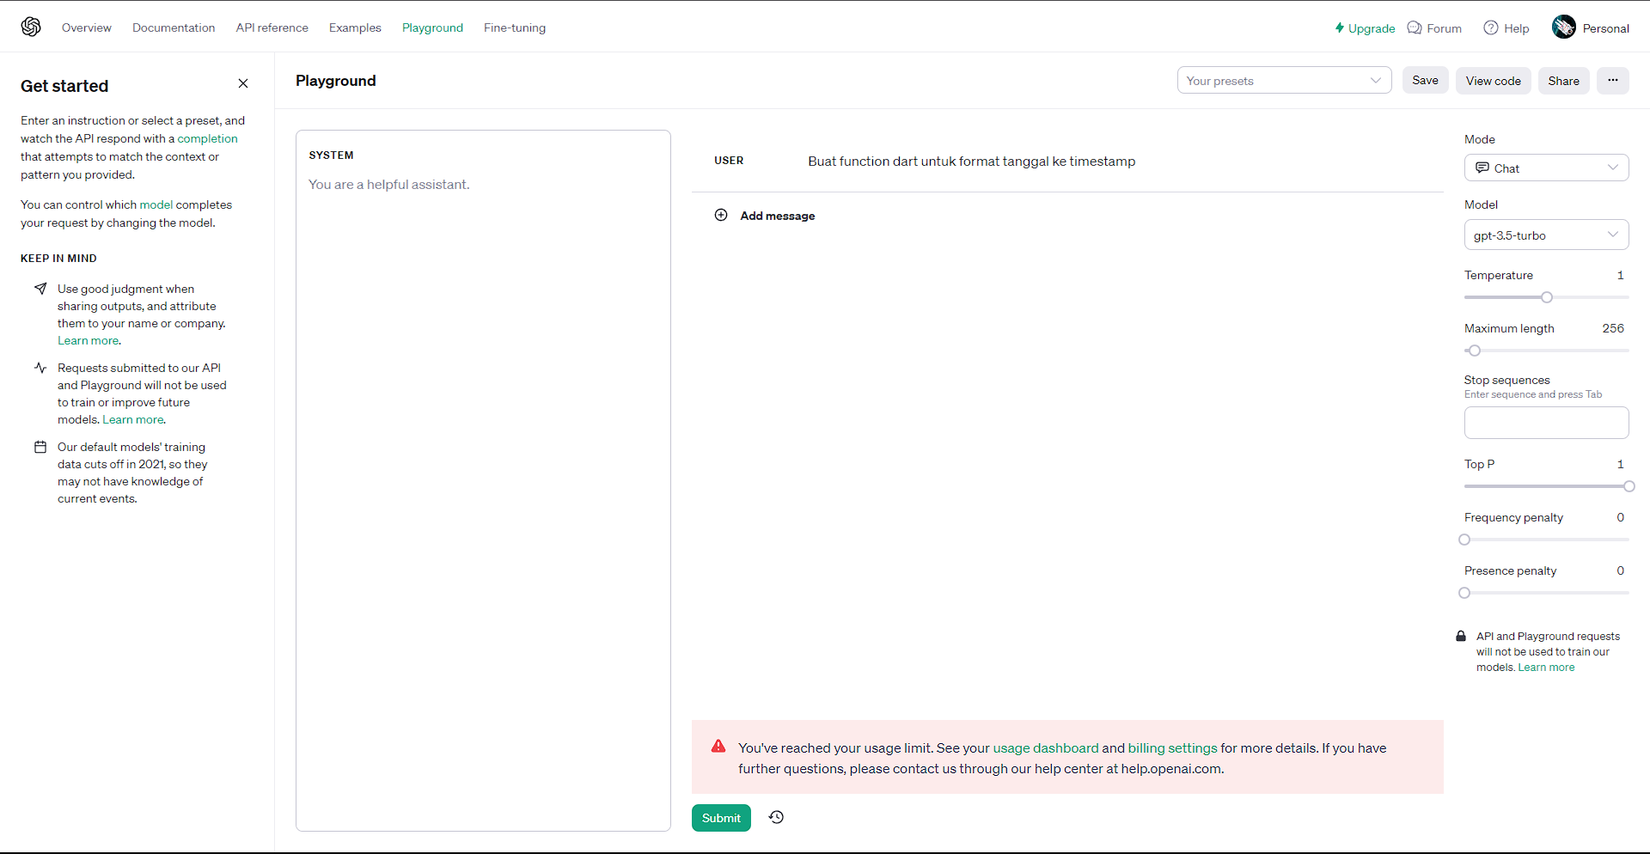

**Input:**

Buat function dart untuk format tanggal ke timestamp

**Output: (Limit Error)**

You've reached your usage limit. See your [usage dashboard](https://platform.openai.com/account/usage) and [billing settings](https://platform.openai.com/account/billing) for more details. If you have further questions, please contact us through our help center at help.openai.com.

1. Google Makersuite

**Screenshot:**

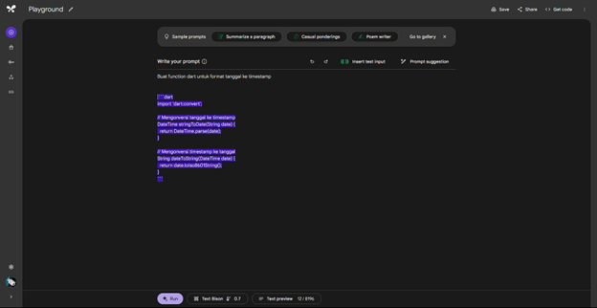

**Input:**

Buat function dart untuk format tanggal ke timestamp

**Output:**  
  
```dart

import 'dart:convert';

// Mengonversi tanggal ke timestamp

DateTime stringToDate(String date) {

return DateTime.parse(date);

}

// Mengonversi timestamp ke tanggal

String dateToString(DateTime date) {

return date.toIso8601String();

}

```